**i) LED BLINKING**

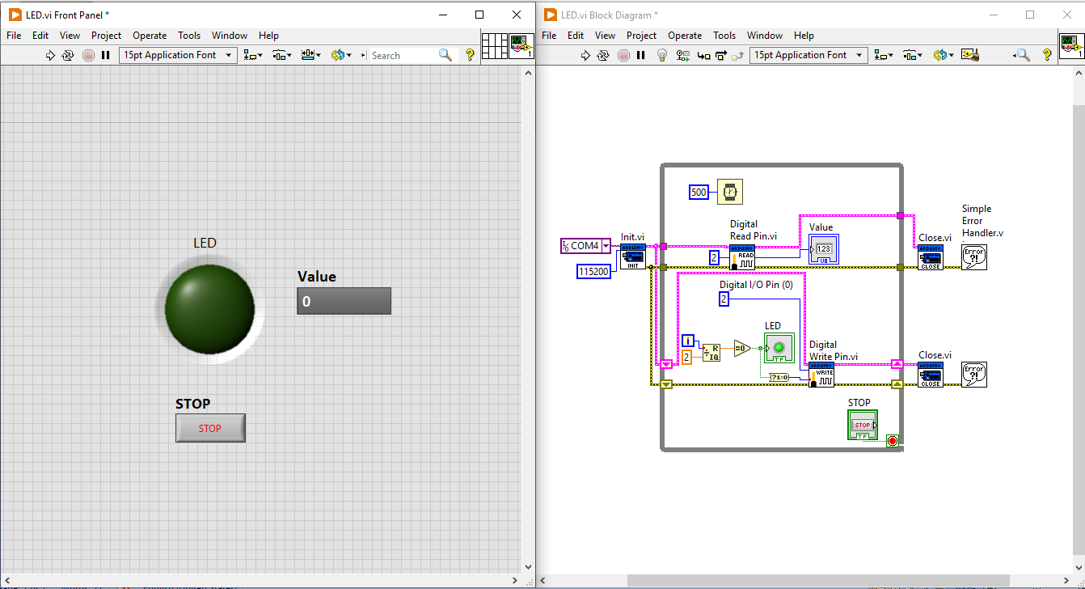

**ii) RELAY INTERFACE USING ARDUINO :**

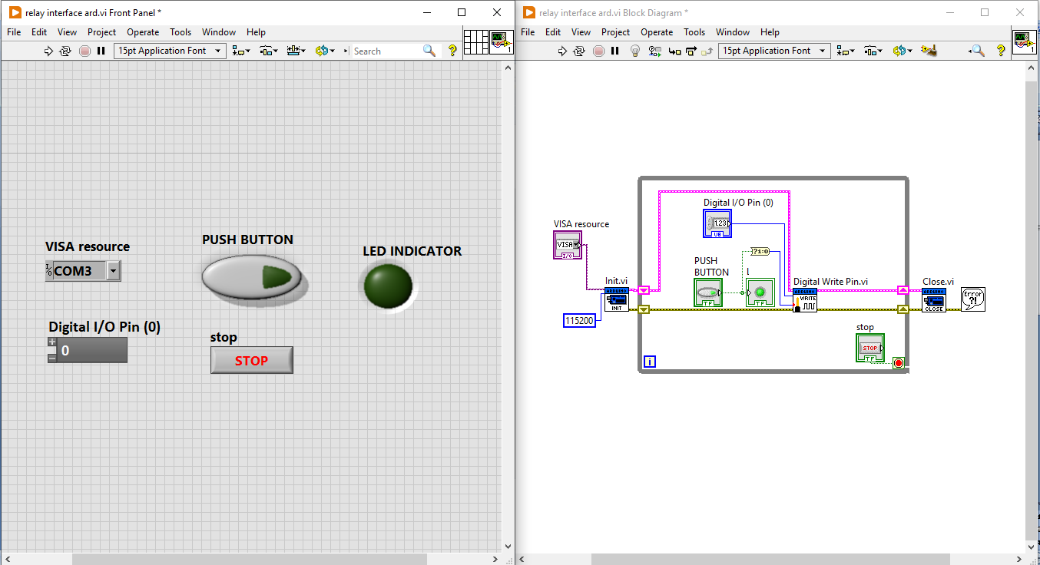

**iii) LM 35 INTERFACING WITH ARDUINO BOARD:**

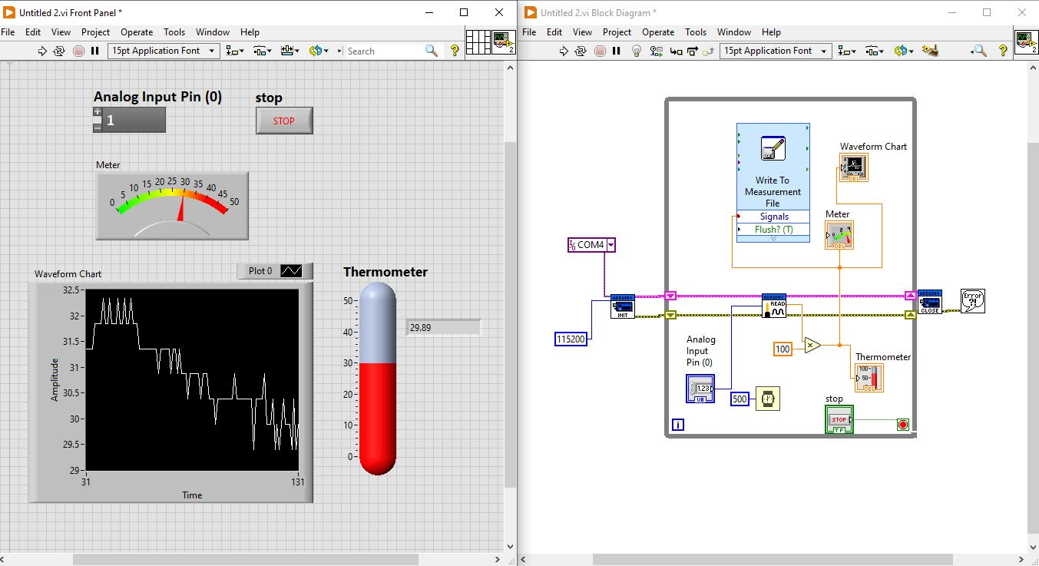

**IV) LED INTENSITY CONTROL USING PWM**

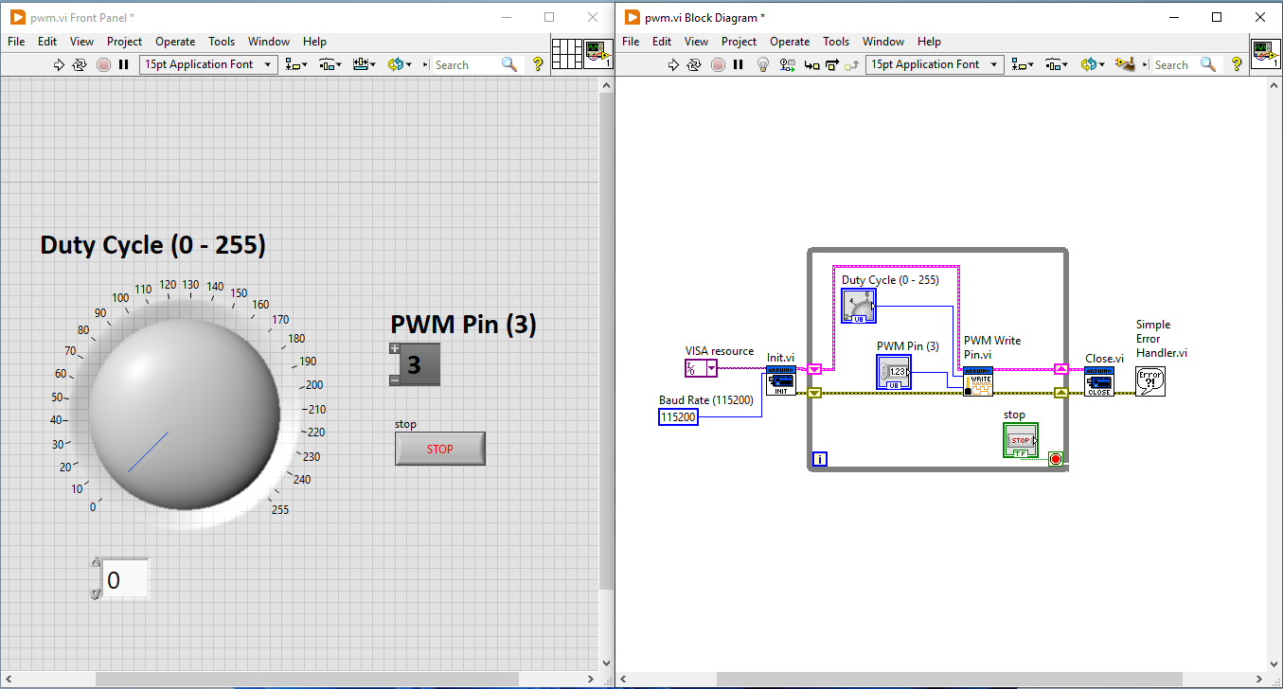

**v) IR PAIR INTERFACE USING ARDUINO :**

